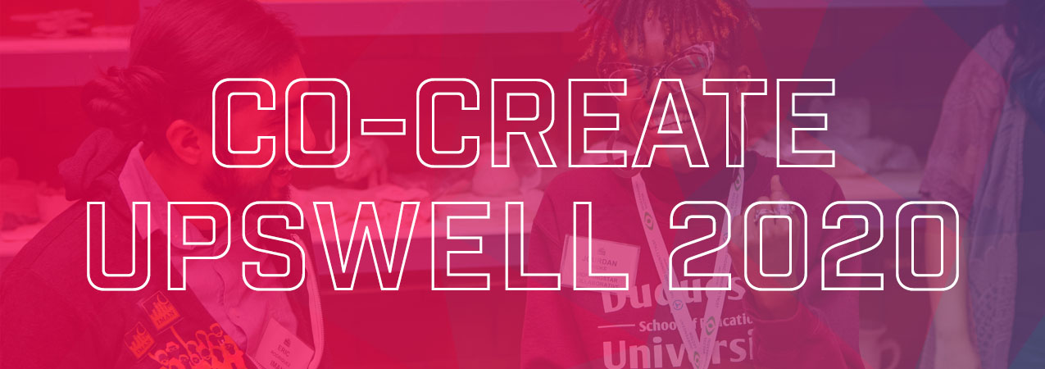
Social Media

The biggest event for social good is now accepting proposals through 4/24! Upswell 2020 will be a powerful opportunity to capture the imagination of the nation’s brightest doers and dreamers by elevating the very best thinking and boldest ideas – including yours. bit.ly/39lB2DO

Email & Newsletter

Elevate Your Ideas to the National Stage
Imagine the enormous potential when thousands of changemakers – each one with unique perspectives, experiences, and skills – gather in Pittsburgh this October 14-16 for Upswell. From quick talks to creative problem-solving to bold prototyping (and, really, anything else that you think would make a real difference in the world), don’t miss your chance to submit a proposal for a wide range of activities on the Upswell 2020 schedule. Proposals are being accepted through April 24. Learn more here: https://upswell.org/co-create

